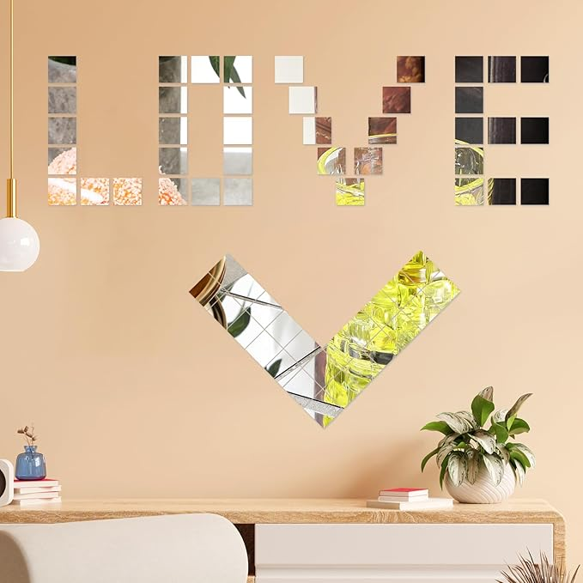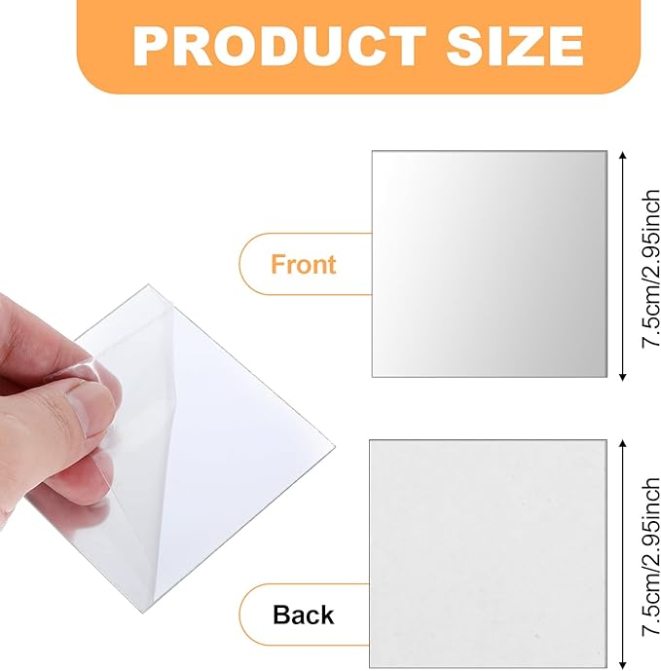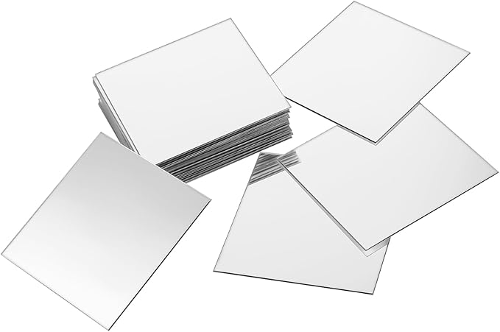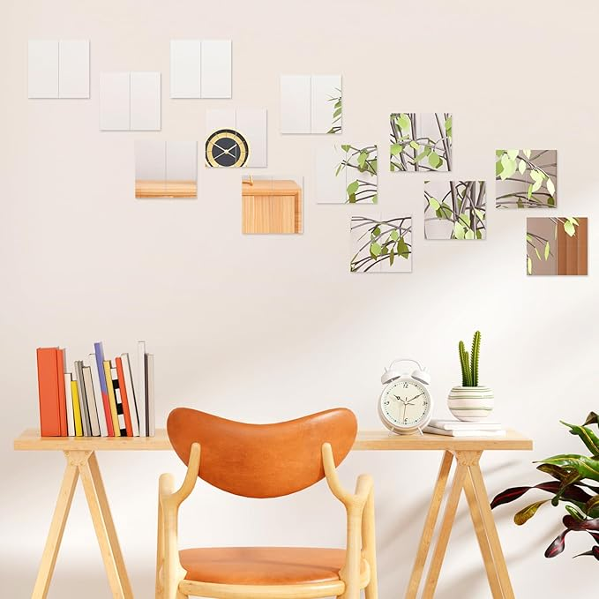

25 Pcs Square Mirror Tiles 7.5cm Acrylic Square Mirror Sheets Self Adhesive Flexible Frameless Mirrors Tile for Wall Non-Glass Safety Reflective Suitable for DIY Craft Home Wall Decoration

**PRODUCT DESCRIPTION:**

Brand Telooco

Material Acrylic

Size 3"L x 3"W

Color Colorless

Product Dimensions 2.95"L x 2.95"W

Shape Square

**About this item**

[Package Content]25 Pcs square adhesive mirrors for wall, sufficient quantity, excellent quality, can be freely combined into geometric patterns or creative collages, mirror tile with OPP independent packaging, whether for personal use or gift giving, it is your best choice

[Acrylic Material] All self adhesive mirror sheets are made of acrylic (PETG plastic), which is durable, smooth surface, excellent texture, not easy to break and deform. The surface of sticky mirrors for wall is covered with a protective film to prevent scratches during transportation and storage, which needs to be torn off before use

[Size Details] Each square mirror stickersr is about 2.95 x 2.95 inches / 7.5 x7.5 cm long and wide, easy to carry or use, also easy to store, does not take up too much space, suitable for dyeing or painting

【Wide Application】Acrylic adhesive mirror is widely used in DIY projects, interior and wall decoration. Flexible mirror sheets self adhesive can be pasted on smooth surfaces such as walls and furniture. It is suitable for a variety of scenes, such as bedrooms, living rooms, dressing rooms, offices, kitchens, gyms, etc., to meet the needs of different users. The reflective effect of mirror stickers for walls can expand the visual effect of the space and make the space appear more spacious and bright

[Note] The surface of the self adhesive mirror is covered with a blue protective film to prevent damage and scratches, please tear it off before use. Tips: The place to peel and stick the mirror is preferably on a smooth surface to prevent bubbles. Sticker mirrors for wall are not real mirrors